COVID-19 Vaccine Safety Literature Review Presented on VIEW-hub

Methods

Updated March 23, 2023

Prepared by:
International Vaccine Access Center,
Johns Hopkins Bloomberg School of Public Health

and

Coalition for Epidemic Preparedness Innovations

For comments or questions, please contact: Marley Jurgensmeyer at mjurgen4@jhu.edu.
Published studies on the safety of routine use of COVID-19 vaccine assessing serious adverse events following immunization are presented on the COVID-19 safety module on the VIEW-hub.org website. Here we describe the methods for identifying published studies, which were developed in collaboration with input from CEPI. Standardized methodology has been developed by the WHO and CDC.

A search of the published literature for COVID-19 vaccine safety studies assessing adverse events following immunization (AEFI) was conducted January 27, 2023. See Appendix 2 for literature search terms. AEFIs identified classified as an adverse event of special interest classified according to the Brighton Collaboration shown in Appendix 1 were searched for specifically by name to broaden search.

Titles and abstracts were reviewed to identify possible relevant studies. Full-text review was performed to evaluate inclusion criteria. Pre-prints later found to be published were excluded.

Inclusion Criteria:
- Studies Indexed in PubMed (including pre-prints) and published prior to January 27, 2023
- Evaluated active vaccine safety surveillance or cohort event monitoring studies
- Evaluated routine use of COVID-19 vaccines

Exclusion Criteria:
- Case reports and case-series studies
- Cross-sectional studies
- Safety evaluated in context of clinical trials, immunogenicity studies or effectiveness studies
- Analyses of passively collected safety data (e.g., VAERS, VigiBase)
- Studies evaluating diagnostic or detection methods of safety events
- Systematic reviews (but the citations of some highly relevant systematic reviews are reviewed to broaden sensitivity, however, this was not systematic)

This project was conducted by: Maria Deloria Knoll, PhD, Parisa Shamaei Zadeh, Marley Jurgensmeyer, and Carmen Villamizar Jaimes at the International Vaccine Access Center, Department of International Health, Johns Hopkins Bloomberg School of Public Health, Baltimore, Maryland, USA; Emmanuelle Espié, DVM, MPH, PhD, and Rebecca Chandler, MD, at the Coalition for Epidemic Preparedness Innovations (CEPI), Oslo, Norway; and Noha Iessa, MPharm, PhD, and Shanthi Narayan Pal, MD, at the World Health Organization (Headquarters), Geneva, Switzerland.

Funding: Support for this project was provided by the Coalition for Epidemic Preparedness Innovations (CEPI).

Appendix 1: Adverse Events of Special Interest

Specific studies classified as Adverse Event of Special Interest (AESI), as determined by the Brighton Collaboration, were sought for specifically in the search criteria, among other studies (see Appendix 2 below). The Brighton Collaboration created a list of AESIs pertaining to COVID-19 vaccines (below and here). The AESIs are categorized according to level of association: those seen with COVID-19 disease, those that have a proven or theoretical association with immunization in general, and those that have a proven or theoretical association with specific vaccine platforms.

Articles that describe any AESIs on the Brighton Collaboration list are flagged as having that AESI. Articles with specific AESIs are flagged and can be searched for on the VIEW-hub safety module.

Table. Brighton Collaboration list of Adverse Events of Special Interest (AESI)
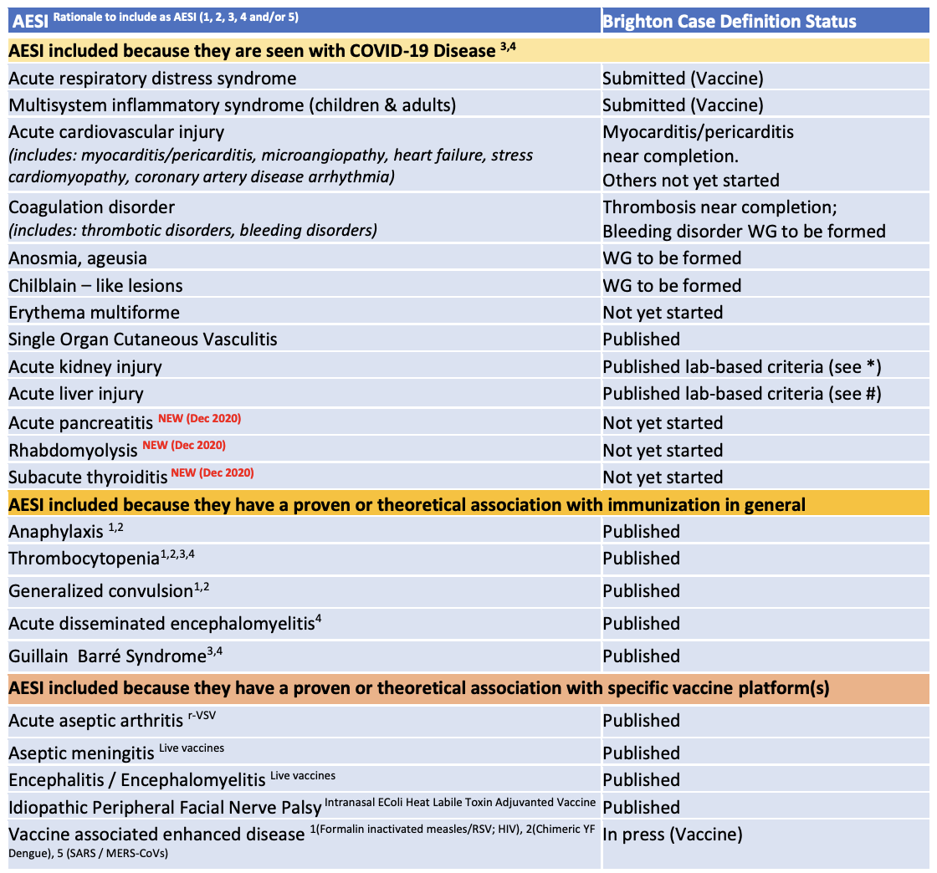
¹Proven association with immunization encompassing several different vaccines
²Proven association with vaccine that could theoretically be true for novel COVID-19 vaccines
³Theoretical concern based on wild type disease immunopathogenesis
⁴Theoretical concern related to viral replication during wild type disease
⁵Theoretical concern because it has been demonstrated in an animal model with ≥ 1 vaccine platform
*Acute kidney injury – international consensus definition proposed by the Kidney Disease Improving Global Outcomes expert consensus group (www.kdigo.org)
- Increase in serum creatinine by ≥ 0.3 mg/dl (≥26.5 umol/l) within 48 hours; OR
- Increase in serum creatinine to ≥ 1.5 times baseline, known or presumed to have occurred within prior 7 days OR
- Urine volume ≤0.5 ml/kg/hour for 6 hours
# Acute liver injury – definition as used in majority of COVID-19 publications (but no international consensus):
- > 3-fold elevation above the upper normal limit for ALT or AST OR
- > 2-fold elevation above the upper normal limit for total serum bilirubin or GGT or ALP

Appendix 2: Literature Search Terms

PubMed:

(( ("Severe Acute Respiratory Syndrome"[mesh] OR “SARS” [tw] OR “SARS-CoV-2” [tw]) AND “vaccin*"[tw] OR ("COVID-19 Vaccines"[mesh] OR "COVID 19 Vaccin*"[tw] OR "COVID19 Vaccin*"[tw] OR "COVID-19 Vaccin*"[tw] OR "SARS-CoV-2 Vaccin*"[tw] OR "Coronavirus Disease 2019 Vaccin*"[tw] ) )

AND

( ("adverse effect*"[ti] OR "adverse event*"[ti] OR "safety"[ti] OR "side effect*"[ti]) OR ("Myocarditis" [tw] OR "pericarditis" [tw] OR "Guillain-Barre Syndrome"[mesh] OR “Acute Inflammatory Polyneuropath*” [tw] OR "Guillain-barre syndrome"[tw] OR "acute autoimmune neuropath*"[tw] OR " Acute Infectious Polyneuritis"[tw] OR "Facial Paralysis"[Mesh] OR “Facial Pals*” [tw] OR "facial paralys*"[tw] OR “Encephalomyelitis, Acute Disseminated”[mesh] OR “Post-Vaccinal Encephalitis” [tw] OR "Thrombocytopenia"[Mesh] OR “Thrombopenia” [tw] OR "Anosmia"[Mesh] OR “ Smell Loss” [tw] OR "loss of smell"[tw] OR "Ageusia"[mesh] OR “ Taste Loss” [tw] OR "loss of taste" [tw] OR “Anaphylaxis” [mesh] OR “anaphylactic Shock” [tw] OR “ Anaphylactic Reaction” [tw] OR “ Blood Coagulation Disorders” [mesh] OR "Blood Coagulation Disorder*"[tw] OR “Seizures” [mesh] OR “Convulsion” [tw] OR "seizure*"[tw] OR "Petit Mal"[tw] OR "grand mal"[tw] OR “vaccine associated enhanced disease”[tw] OR “acute cardiovascular injury”[tw]) )

AND

( ("observational" [tiab] OR "follow-up study" [tiab] OR "prospective*" [tw] OR "longitudinal" ) OR "study"[tw] OR "rates"[tw] OR "incidence"[tw] OR ("product surveillance, postmarketing"[Mesh] OR "post-marketing"[tw] OR "postmarketing"[tw] ) ))

NOT hesitancy [ti] NOT attitude[ti]
NOT "cross-sectional"[tw] NOT ("case*"[ti] AND "report"[ti]) NOT "predict*"[ti] NOT "case study"[ti]

NOT "review"[publication type] NOT "Systematic Review"[publication type] NOT "Systematic Review"[tw]
NOT "Clinical Trial" [Publication Type] NOT "Controlled Clinical Trial" [Publication Type] NOT "trial" [tw]

Covid-19 vaccines: safety surveillance manual. (https://apps.who.int/iris/handle/10665/338400, accessed 3 May 2023).
Centers for Disease Control and Prevention. V-safe active surveillance for COVID 19 vaccine safety 2020 [updated 19 November 2020; cited 2021-01-15], (https://www.cdc.gov/vaccinesafety/pdf/V-safe-Protocol-508.pdf, accessed 3 May 2023).

